Spring 2022 Schedule and Guide
For play beginning June 4, 2022

Camano Stanwood Pickleball Association now counts well over 250 members with a wide range of experience and skill levels; use this guide to help you visualize our current playing schedule and the best matches for your skill level and preferred playing format.

Find Your Skill Level
Use the attached Ratings Finder from Pickleball Guru to identify your skill level (newbie through expert).

Schedule Summary
A summary of the schedule and targeted skill levels is shown below. Remember that the courts are also available at other times of the day on a first-come, first-served basis for self-arranged groups to play. The tennis group generally has courts reserved Sunday–Friday from 8-11 am.

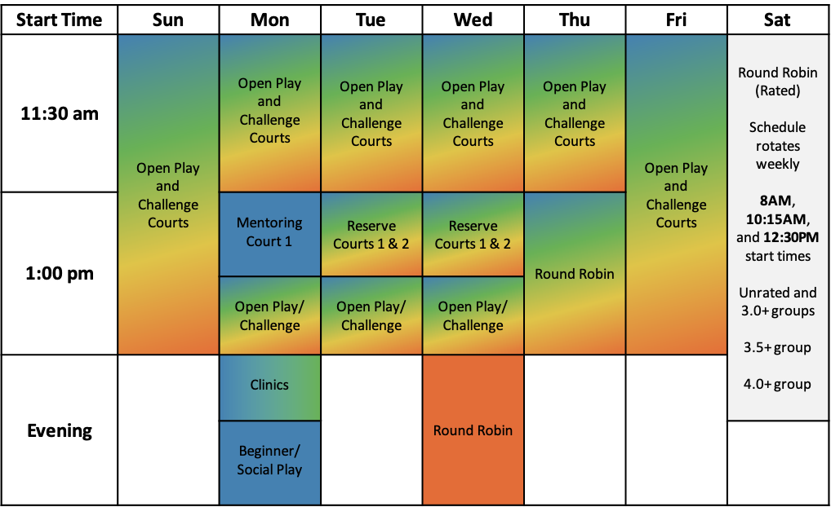

Key | Beginner/  Novice | Intermediate | Advanced/  Expert

Understand Play Formats
For our spring 2022 schedule, we have the following play formats on the schedule:

Beginner/Social Play: Non-competitive play that provides a welcoming opportunity for new and developing players to exercise and improve their skills and meet other players, and for more advanced players to meet newer players and work on their soft game and consistency. Sign up for this specific format, but players may choose to rotate around social play courts.

Clinics: Formal instructional clinics targeted at specific skills and skill levels. Requires clinic registration, and may require an additional fee.

Mentoring: Informal but structured play where mentors and experienced players help introduce new players to the rules and play of pickleball, and tips to help more advanced/intermediate players. Players interested in a mentoring session will be able to sign up within the SignUp Genius app, and coordinate with the program director for more information.

Open Play with Challenge Courts: Players rotate on and off of courts on a first-come, first-served basis, placing paddles in a rack to “wait in line.” Challenge courts provide a more competitive, don’t-hold-back challenge for more advanced players using a separate queue. See detailed Open Play/Challenge Court guidelines, attached. Registration for open play is to manage overall court capacity so that wait times don’t grow too long.

Round Robin: Informally structured round robin where each player plays with and against different players each game. Register for the round robin and the host will assign specific teams and courts for each game at the time of play.

Round Robin (Rated): The same as Round Robin but requires a club or USAPA/UTPR rating for a specific skill level, except for players choosing the Unrated group. This Club Rating requirement will be strictly enforced for the Saturday Round Robin time slots.

Find Your Skill Level
From The Pickleball Guru LLC

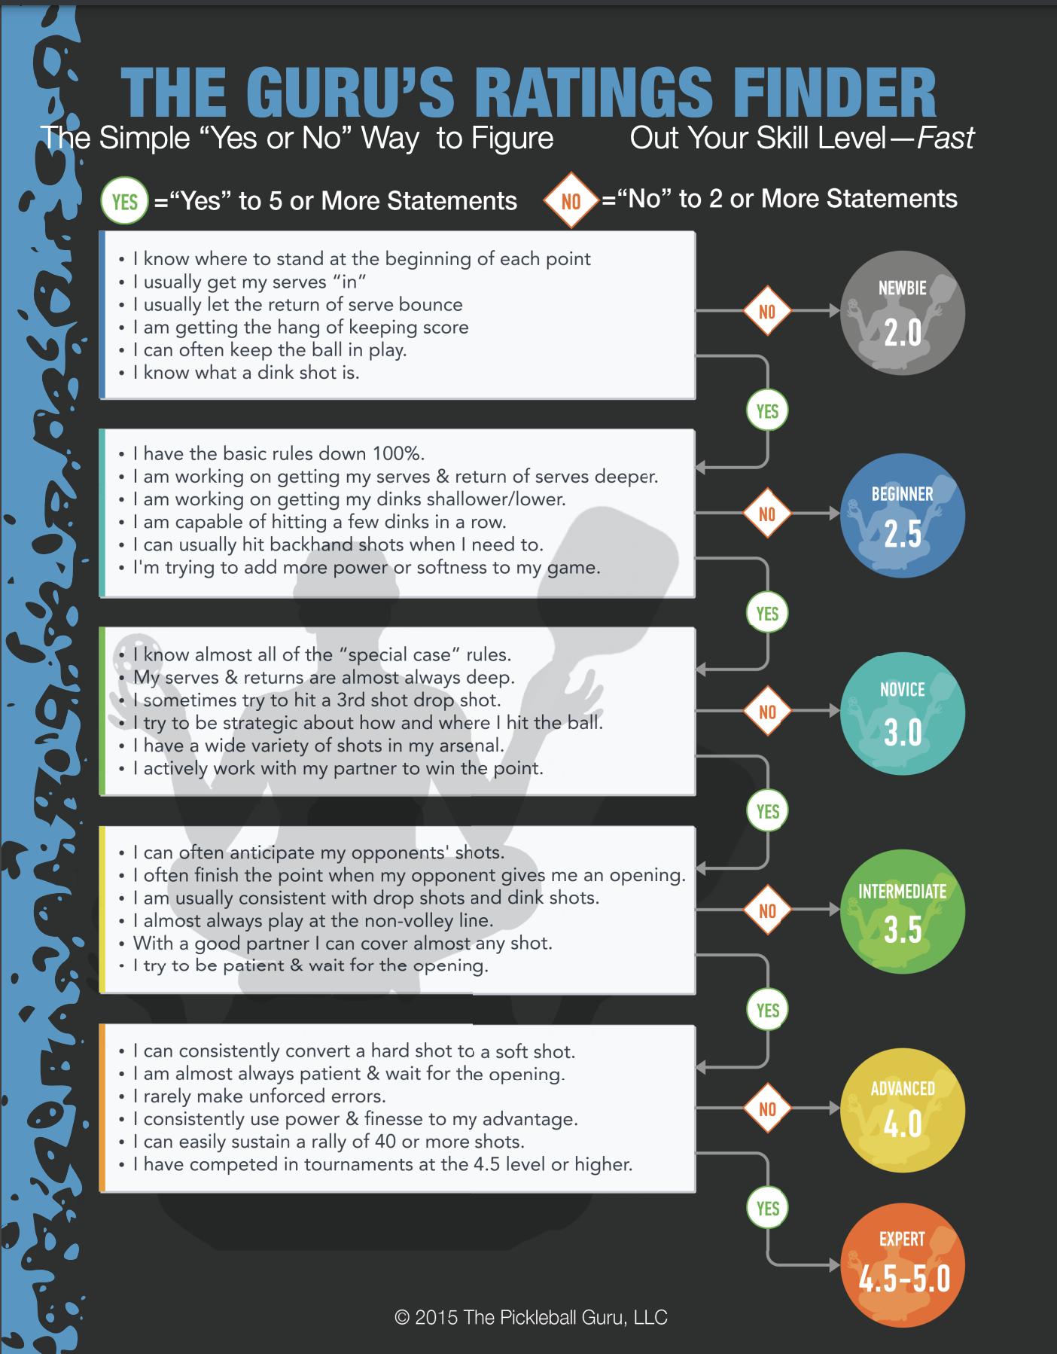

Open Play/Challenge Court Guidelines
Adapted from Kona Pickleball Hui

Challenge Court – Courts 4 & 6
The purpose of a challenge court is to:
- Allow advanced players the opportunity to play competitive games.
- Provide intermediate players the opportunity to step away from open play and test themselves.

Challenge Court Rotation of Play Guidelines
- Paddles must be queued up for play on the challenge court.
- While the challenge court is intended for intermediate to advanced play, ANY player may elect to play on the challenge court, and no other player may discourage or restrict them from doing so.
- Players electing to play on a challenge court should understand that all players on this court are expecting a challenging game and will not be expected to 'go easy' on anyone.
- Teams stay together on this court.
- No team or individual player plays more than two consecutive games on the challenge court.
- When a game ends and there are 7 or fewer players waiting for the challenge court, the winning team stays on and stays together after their first win, and a new team comes in to challenge them. The second-place finishers come off the court.
- If a team wins a second consecutive game or there are 8 or more players waiting to play, then all players exit the court and two new teams (4 players) come on.
- Players are encouraged not to play exclusively on the challenge court. Our most advanced players should consider themselves ambassadors of the sport, and as such, are encouraged to play some games on the open play courts and to use those games to mix with other players and to practice aspects of their soft game.

Open Play Courts – Courts 1, 2, 3
The purpose of open court play is to:
- Play and socialize with ALL members of our pickleball community
- Provide a variety of mixed-skill level games, so that
  - Players with similar skill levels have opportunities for competitive games.
  - Players with less advanced skills have opportunities to challenge themselves against players with more advanced skills
  - Players with more advanced skills have opportunities to practice the soft game elements of pickleball (dinking, placement, soft third shots, soft blocking, etc.)

Open Court Rotation of Play Guidelines

- Paddles must be queued up for open play.
- Standard play rotation is “2 out, 2 in”; once 8 or more paddles are in queue, rotation will be “4 out, 4 in”.
- Under “2 out, 2 in”, when a game ends, the winners stay on and split up. The second-place finishers come off the court and rejoin the end of the queue.
- Under “4 out, 4 in”, when a game ends, all 4 players come off the court and both teams rejoin the end of the queue.
- If a player or group of players is next in queue but wishes to delay their play (e.g., waiting for a specific opponent to become available or waiting for a less challenging opponent), they can allow the player(s) behind them to move ahead.

